**Md. Masudur Rahman Khan** 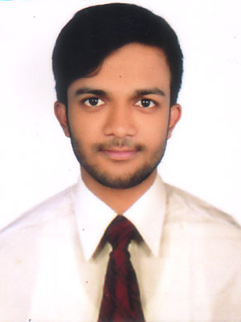

C/O: Md. Abu Bakkar Khan

Vill: Pump House Colony, P.O: Power House,

P.S: Bheramara, Dist: Kushtia.

Cell**:** 01731-343303

**Key Objective**

It is a notion of my quality to secure a challenging position within progressive organization, where I can utilize my experience, technical skills, creativity and capability to work on own initiative and as part of a team. I want to build my career in work. I am very energetic, hardworking and ambitious person.

**Educational Qualification**

**Secondary School Certificate (S.S.C)**

**Institute :** Bheramara Pilot High School

**Board :** Technical Board

**Subject :** Building Maintenance

**Result :** GPA- 4.79(Out of 5.00)

**Passing Year :** 2015

**Diploma in Power Technology**

**Institute :** Khulna Polytechnic Institute

**Board :** Technical

**Group :** Power Technology

**Result : 3.09**

**Passing Year :** 2019

**Language Proficiency**

**1. English :** Fair reading, writing and speaking ability

**2. Bengali :** Mother tongue

**Computer Knowledge**

**Documentation :** Microsoft Word, Excel, Excess.

**Presentation. :** Ms Power Point

**Internet Application :** E-mail, Browsing, Web Searching.

**Training**

**Nwpgcl electrician training 2 month**

**Six Month Training for Auto Mechanics Under UCEP.**

**Personal Attributes**

* Young energetic. enthusiastic and self motivate.
* Good communication and interpersonal skills.
* Good analytical skills in problem solving area.
* Ability to work under pressure.

**Personal Details**

**Full Name : Md. Masudur Rahman Khan**

**Father's Name :** Md. Abu Bakkar Khan

**Mother's name :** Mst. Aklima Khatun

**Date of Birth :**  10-12-1999

**Sex :** Male

**Height :** 5' . 6"

**Weight. :** 60 kg

**Blood Group :** O+ (positive)

**Nationality :** Bangladeshi (y birth)

**National ID No. :** 6904967228

**Marital Status. :** Unmarried

**Religion :**  Islam

**Permanent Address**

Village : Pump House Colony

Post Office : Power House

Police Station : Bheramara

District : Kushtia

**Declaration**

I, undersigned do hereby certify that this C.V correctly describes my qualifications and myself.

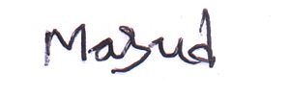

Signature

Date: 11-05-2019